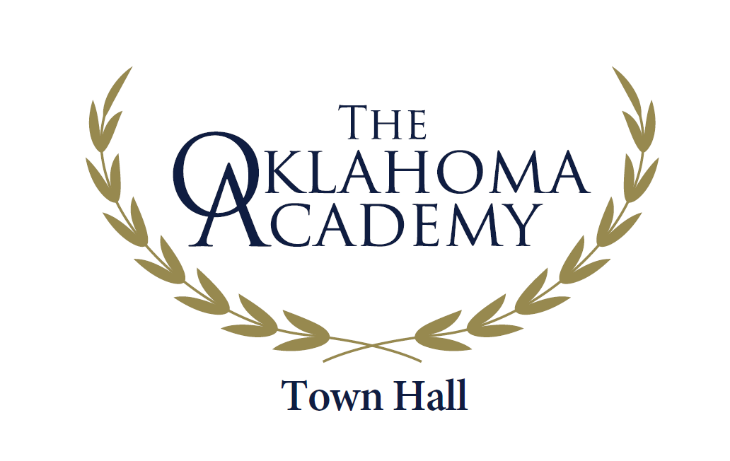

Dear Oklahoma Leader,

The 2021 Town Hall Conference Retreat has a specific and purposeful focus on a critically important issue for Oklahoma’s future – addressing mental health to improve mental wellness. Please see the enclosed piece that describes this timely and important Town Hall focus.

Town Hall Steering Committee Co-Chairs Anne Roberts, Oklahoma City University, and Richard Wansley, Ph.D., Advocate, LLC, along with the Research Committee Chair and Steering committee members have been working since February 2020 identifying the major areas of focus, the necessary data and information for the background resource document, and identifying plenary session speakers for the Town Hall. The Town Hall will focus on the impacts of mental health on children and families, on Oklahoma’s education system and our existing and future workforce, the effects on our criminal justice system, and on the productivity of Oklahoma businesses.

The success of any Oklahoma Academy Town Hall Conference Retreat depends upon having a diverse group of participants. We follow a nomination process to secure those who are interested in participating. From the nominee pool, we select people to participate who are statistically reflective of Oklahoma’s diverse population, as well as those who recognize the importance of the topic. Once we have received all nominees, invitations to participate are sent to those selected from the nomination pool thereby allowing us to have a participation group that as much as possible socio-demographically represents Oklahoma’s population. The Town Hall Conference requires full-time attendance from Sunday evening through Wednesday noon; it is not a “come and go” conference.

If you are interested in being considered as a participant, please complete the attached Nomination Application and email it back to the Oklahoma Academy by the final deadline of May 31, 2021. If you know others who would be interested, please feel free to duplicate the form and topic explanation sheet and share with them or complete it for them, letting them know you have done so. Invitations to participate are mailed by mid-August at the latest.

If you know you are not able to participate in the full three-day conference, you may want to be an Observer; please contact April Maddry in the Academy office at 405.307.0986 or email her at april@okacademy.org.

The Town Hall conference process is dynamic; it allows for excellent discussion and collaborative development of sound policy and community action recommendations. The findings report and recommendations are fully developed by the close of the Town Hall Wednesday noon and participants leave knowing what they have created. Once all grammatical and formatting steps are checked, the completed Findings & Recommendations Report is printed and provided to Town Hall participants and Oklahoma Academy members. An official press conference is held in January in the Blue Room at the Capitol to officially release the Town Hall Findings & Recommendations to the Governor, legislative leadership, media, the Academy membership and to other appropriate entities. Planned forums and sharing events are held in communities across the state shortly after the findings are officially released. Implementation work begins!

Should you have any questions, please call the Oklahoma Academy office at 405.307.0986.
2021 Town Hall Specifics
Date: November 7th – 10th, 2021 River Spirit Hotel & Casino, Tulsa, OK
Topic: Addressing Mental Illness ~ Improving Mental Wellness
Costs: Specifics on registration fee and lodging will be provided upon receipt of the completed nomination form.

Sincerely,
Julie Knutson
Oklahoma Academy President/CEO

